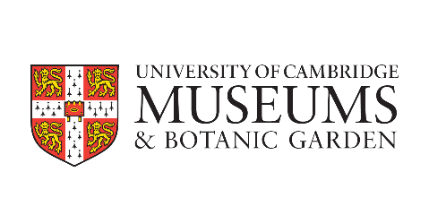

Cambridge AHRC DTP University of Cambridge Museums Internship

Expression of Interest

Student details

Name
Student’s email
Department
Supervisor name
Supervisor’s email
Date of start of PhD
Title of PhD
PhD summary (100 words max, written for a general audience)

Internship project:
Project details and desired outcomes
Please indicate your preferred UCM internship opportunity and explain in 300-500 words why you are interested in it.
If you are interested in more than one opportunity, please list the projects in order of preference. Please explain why you are interested in each one.
Describe how your research would enable you to contribute to your preferred project(s), and more broadly to UCM’s examination of the impact of colonialism, enslavement, and/or racial inequality in our collections. Areas of focus could include: the power structures behind knowledge and communication; display choices and language use; object stories – especially those that cross different collections; who collected the objects and how; visual theory; judgements about aesthetic value; methodological and ethical stakes of investigating racism, silencing, and counter-narratives; how the collections research should inform returns policy and acquisitions policy.
Please note that this is not an exhaustive list. These projects are suitable for students with an interest in areas including but not limited to: decolonisation; working with material culture; interrogating elite and/or popular material culture and discourse; bringing research to bear on challenging items of material culture in order to tell stories about them; developing critical approaches to the collections which link to current concerns about the legacies of imperialism. There is scope to make the project your own and apply your particular research expertise in a museum context.
How will you benefit from the internship?
What skills or insights do you hope to gain? How do you hope to use those skills or insights going forward?
How will how will University of Cambridge Museums benefit from hosting you as an intern?
What skills, knowledge or insights would you bring to the project?
Internship timing / duration
Please confirm that you can undertake a 3-month internship on a full-time basis, starting on Monday 28 February 2022.
That start date must be before the end of your current Covid-adjusted funded period. If funded by SDF, the internship must end before your current Covid-adjusted submission deadline and actual submission of your thesis. If funded by another body, please check their rules on timing.
Signature and Supervisor’s Approval
Student  Please sign to indicate that you wish to be considered for a UCM internship, and to confirm either that you are eligible for an SDF extension because your maintenance is fully or partially funded by the AHRC, or that your maintenance provider is willing to offer you an extension for internship activity on similar terms. In the latter case, please provide evidence of the offer from your maintenance provider. By signing, you also confirm your understanding that an SDF extension provides funding for an additional period equivalent to the length of the internship, but no equivalent submission deadline extension. Funding from other maintenance providers is likely to be subject to the same restriction, unless they agree to fund you during a formal intermission from study. Please check. | Name:
 | Date:
 | Signature:
Supervisor  Please sign to indicate that you approve this application, and understand that an AHRC DTP SDF extension provides the student with funding for an additional period equivalent to the length of the internship, but no equivalent submission deadline extension. | Name:
 | Date:
 | Signature:
Director of Graduate Studies  or Chair of Degree Committee  Please sign to indicate that you approve this application, and understand that an AHRC DTP SDF extension provides the student with funding for an additional period equivalent to the length of the internship, but no equivalent submission deadline extension. | Name:
 | Date:
 | Signature:
Please return this completed form by 10 December 2021 to: AHRCDTP@admin.cam.ac.uk.

