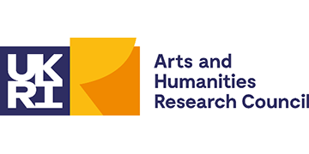
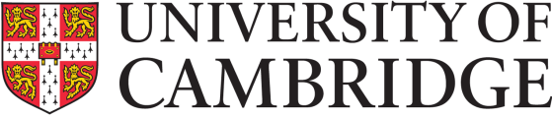
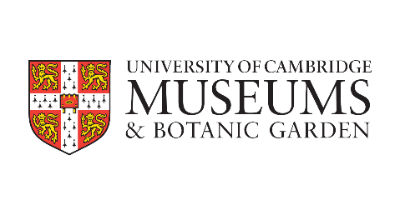

Cambridge AHRC DTP University of Cambridge Museums Internship

Expression of Interest

Student details

Name
Student’s email
Department
Supervisor name
Supervisor’s email
Date of start of PhD
Title of PhD
PhD summary (100 words max, written for a general audience)

Internship project:
Project details and desired outcomes

Please explain in 300-500 words why you are interested in a UCM internship.
Describe how your research would enable you to contribute to the UCM’s examination of the impact of colonialism, enslavement, and/or racial inequality in our collections. Areas of focus could include: the power structures behind knowledge and communication; display choices and language use; object stories – particularly those that cross different collections; who collected the objects and how; visual theory; judgements about aesthetic value; methodological and ethical stakes of investigating racism, silencing, and counter-narratives; how the collections research should inform returns policy and acquisitions policy.
Please note that this is not an exhaustive list. These projects are suitable for students with an interest in areas including but not limited to: decolonisation; working with material culture; interrogating elite and/or popular material culture and discourse; bringing research to bear on challenging items of material culture in order to tell stories about them; developing critical approaches to the collections which link to current concerns about the legacies of imperialism. There is significant scope for making the project your own and applying your particular research expertise in a museum context.
How will you benefit from the internship?
What skills or insights do you hope to gain? How do you hope to use those skills or insights going forward?
How will how will University of Cambridge Museums benefit from hosting you as an intern?
What skills, knowledge or insights would you bring to the project?
Proposed internship timing / duration
What are the proposed timings and duration of your internship?  (Typically 3 months full-time or 6 months part-time and starting between February and April 2021. Must start before the end of your standard funded period, and end before your planned funding extension period. If funded by SDF, must end before your submission deadline and actual submission of your thesis.) |  |  |  | Start / finish date (or must start / finish by)
Signature and Supervisor’s Approval
Student  Please sign to indicate your wish to be considered for a UCM internship, and to confirm either that you are eligible for an SDF extension because your maintenance is fully or partially funded by the AHRC, or that your maintenance provider is willing to offer you an extension for internship activity on similar terms. In the latter case, please provide evidence of the offer from your maintenance provider. | Name:
 | Date:
 | Signature:
Supervisor  Please sign to indicate that you approve this application, and understand that an AHRC DTP SDF extension provides the student with funding for an additional period equivalent to the length of the internship, but no equivalent submission deadline extension. | Name:
 | Date:
 | Signature:
Director of Graduate Studies  or Chair of Degree Committee  Please sign to indicate that you approve this application, and understand that an AHRC DTP SDF extension provides the student with funding for an additional period equivalent to the length of the internship, but no equivalent submission deadline extension. | Name:
 | Date:
 | Signature:

Please return this completed form by 30 November 2020 to: AHRCDTP@admin.cam.ac.uk

